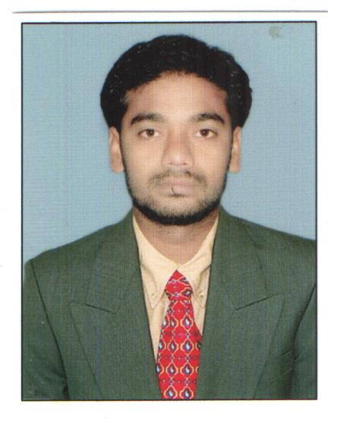
RESUME

PRAKASHA RAO BONE

C/o P.Ramulu

Plot No: 10

Indira Nagar Colony,

Surdarayya Nagar,

Srikakulam. Pin: 532001.

Mobile : 8374548028

prakashbone@gmail.com

CAREER OBJECTIVE:

Intend to build a career with leading corporate of hi-tech environment with committed & dedicated people, which will help me to explore myself fully and realize my potential. Willing to work as a key player in challenging & creative environment.

EDUCATION QUALIFICATION :

- MBA from Sri Sivani College of Engineering (affiliated to JNTU Kakinada)

- Graduation from Govt. Degree College, Narasannapeta (affiliated to AU).

- Intermediate from Govt. junior College, Srikakulam

EXPERIANCE:

- Worked as R.S.O. (Rural sales officer) in Bajaj Allianz insurance company at srikakulam, for seven months in (Nov-23- 2010 to May-30-2011)
- Woked as a Coex in HDFC BANK for (Dated: 01-June 2011- to- 07- may- 2012), Srikakulam.
- Still Working as a ASSISTANT MANEGER SALES Role in Axis Bank in Srikakulam.(ANDHRAPRADESH)

ACHIEVMENTS:
  - Life Li – Certification in Achievement in 2014
  - Life Insurance in Karthika Vanabhojanam Campaign Achievement for 2 years
  - Life Active Campaign Achievement

SOFTWARE EXPOSURE:

  - MS.Office
  - Internet

STRENTHS:

- Hard Working.

- Positive thinking.

- Adaptability to the changing work environment which enabled me to succeed in my career.

PERSONAL PROFILE:

Name : PRAKASHARAO BONE
Father’s name : B.Kuramayya
Date of Birth : 12-6-1985
Sex : Male
Marital Status : single
Languages Known : English & Telugu
Nationality : Indian
Permanent Address : Prakasha rao Bone

C/o P.Ramulu,

Plot No: 10,

Indira Nagar Colony,

Surdarayya Nagar,

Srikakulam. Pin: 532001.

DECLARATION:

I hereby declare that the information furnished above is true to the best

of my knowledge.

PLACE:

DATE:
(B.Prakasha Rao)

